VAST checklist
Seung Lab

- Save EM VAST file in the root directory as ‘[root folder name].vsv’. Example: (Vol001_Raw.vsv)
- Save VAST annotation file in the root directory as ‘[rootfoldername]_[annotation task type].vsseg’. e.g. ‘rootfoldername_synapses.vsseg’, ‘rootfoldername_cell_segmentation.vsseg’.
- Save your work as you go along.
- Have your annotation reviewed (see the verification policy).
- Export your annotation with the following properties:
  - .TIF (uncomp.)
  - 24bit/px RGB-encoded
  - Check “collapse labels as in current view”
  - Choose to save the images in the directory with the name of the annotation task type (e.g. rootfoldername/synapses, rootfoldername/segmentation)
- Notify project owner that the annotation has been exported.
- If the annotation task type is a cell segmentation, have the project reviewed in Omni (see below on how to Omnify & see the verification policy for how to review)
  - Correct any errors your reviewer catches
  - If necessary, re-export & re-omnify.
  - Notify the project owner that the annotation has been exported.

Screenshots:
Layout of the directory
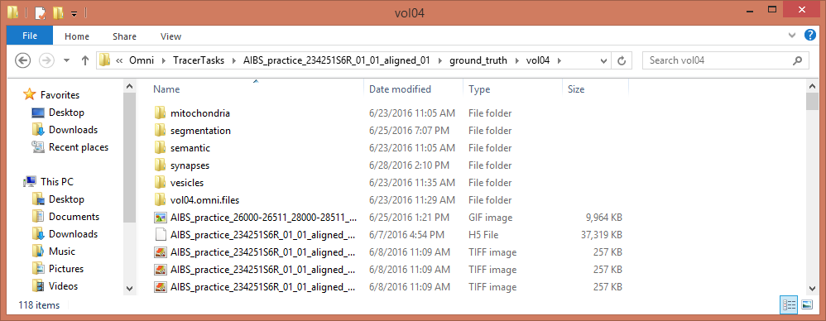

Export window settings
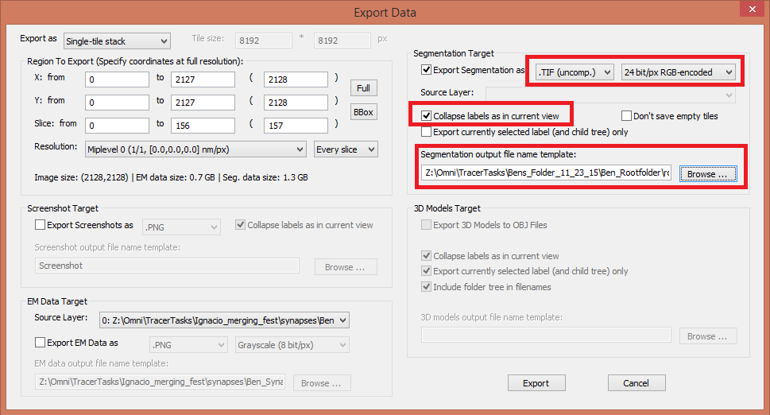

How to omnify a cell segmentation
- Make sure the VAST directory contains a `raw` folder with the EM images, as well as a `cell_segmentation` folder with the exported cell segmentation.
- In Ubuntu, open `terminal` (shortcut: CTRL+ALT+t)
- Make sure the Omni drive has been mounted. If it isn’t, run `mountlab`.
- Change directories to the location of the (changed from VAST) folder that needs to be omnified:
  - cd ~/seungmount/Omni/TracerTasks/[path to the VAST folder] (Note: the path to the VAST folder should stop at the volume folder.
Example: cd~/seungmount/Omni/TracerTasks/AIBS_practice_234251S6R_01_01_aligned_01/ground_truth/vol08
This is because the process pulls from both the Raw Folder and the Cell Segmentation folder)
- Run the python script to omnify the VAST directory:
  - python ~/seungmount/Omni/emirt/omnify_VAST_dir.py

How to Combine Two Image Stack Segmentations
- Make two (or more depending) folders for each half of the segmentation you want to combine.
- Export your files from each segmentation to their representative folders.
- Make sure the name of the exported files is the same.
- Open the EM you want
- Go to File, Import Segmentation From Images …, when the directory opens choose the first half folder and select all the TIF. images you exported
- A window will open. In the window you will see something like vol_27_seg_done_son.vsseg_export_s000.tif
- In this string you will change the 000.tif to %03d.tif We choose %03d instead of say %04d because the images of three numbers in it. If there were four or five it would be %04d or %05d etc.
- Here it is shown corrected: vol_27_seg_done_son.vsseg_export_s%03d.tif
- Then you will change the No of first slice (z): 1 to No of first slice (z): 0
- And No of last slice (z): 1 to No of last slice (z): 49
- This will take the segmentation from the images you selected and crop out all the segmentation that isn’t within those parameters. You can fiddle with the numbers if you want to fit your agenda.
- After you finished changing those hit ok and now it’s time to add the other half.
- Same steps as before. Until you get to changing the slice numbers.
- Change No of first slice (z): 50 and No of last slice (z): 99
- Then at the bottom the Start coordinates: should change Z to 50
- Hit ok and everything should be A ok
How to VAST

Why VAST?
We use VAST to generate ground truth. Ground truth needs to be standardized. Our standards need to be an accurate, valid, and reliable. Meaning we must all generate, export, and proofread precisely. In order to do so we will all hone our skills.

Import EM Images
EM files (black and white pictures of neurons) are created from an image stack. Go to File, Import EM Stack From Images. From here you navigate to the project folder you are assigned and enter the Raw folder in that directory. Here there will be a list of .TIF images. Select them all and hit open. Then hit OK to the two windows that pop up. It will ask you to choose where to save the EM file you just made. Save it in the Raw folder. You’ll name the file the same name as the root folder. e.g. You opened volume2 folder. So your file name is volume2. It will look like volume2.vsv

Open Recent EM/Open Recent Segmentation
Use these choices in the File dropdown to select an EM and then a segmentation you have worked with in the past. (Done typically when VAST needs to be reopened.)

Begin Segmentation
With a fresh EM imported or opened you will start the segmentation or annotation task. Do this by hitting the pencil button under the File dropdown menu. Hit OK. Begin painting.

Welding and Collapsing Labels
When segmenting VAST (painting, tracing) you often run into the scenario where you have traced a segment with two different segment IDs and want to combine them. i.e. You are using segment 6 and all of a sudden you realize that segment 6 should be a part of segment 112! Easy. Drag segment 6 and drop it into segment 112 (or vice versa). This will create a segment sub tree. When the tree is collapsed it will show both segments as one color. From here you can right click the parent segment (the one that has the other segment inside of it) and select weld segment sub tree. OR. You can weld them all at the export phase. (Pro strats)

Exporting Segmentation File
Export when you have finished seg/label and you have been proofread. Go to File, Export. In the export window you will do four things. First and second you will, on the right hand side top corner, click the dropdown menus and select .TIF (uncomp.) and 24bit/px RGB-encoded. Third, in the same corner you will check off the box that says “collapse labels as in current view”. This welds the segments of all sub trees. Lastly you will hit the ”browse” button. Chose the path that leads to the “Segmentation” folder of the current project. Save it as root the folder name. i.e. Volume3. It will look like volume3.vsseg after saved. For labeling synapse, mitochondria, etc. It’s the same procedure except the folder you save in will be their folder representative folders.

Screenshots:
Parent/child setup
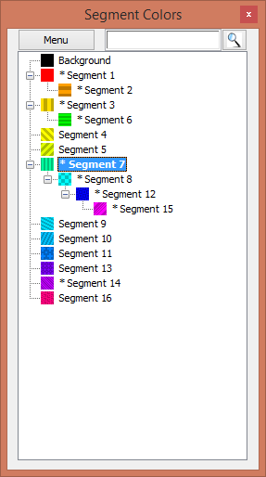
Notes
Small glia or myelin or intercellular space are to be annotated in neuronal segmentation.

How to Review Synapses, Annotate Synapse and Validate Synapses
Annotation
- Begin a new vast project in the data set you wish.
- Click the pencil icon to spawn 16 new segments.
- From here you will name three or four segments
- First, the cleft segments used to color clefts
- Second, the segments used to denote the axon or presynaptic site (Picture/PP) on Slide 42/43
- Third, the segment used to denote the dendrite or postsynaptic site
- The Fourth can be used to denote clefts that you are not entirely sure are synapses (you won’t always use this one)
- Once you have your segments set up you will begin tracing all synaptic clefts, and denoting the presynaptic sites, and postsynaptic sites etc.
Review
- Open Vast project you want to review.
- Start segment by segment and check them out.
- After you checked all the labeled ones you can look for any that were missed
- Turn alpha to a level you like and go slide by slide checking and counting for synapses.
- You can once you find one slide the alpha up to see if they got it.
- If you want to be pro you can utilize the vesicle cloud annotations if they are done for that set yet to help you cross reference.
Validate
- Make sure to save your file with a name that indicates that it was reviewed and validated.
- After the review and save you are finished validating.

